**India Agriculture Crop Production**

1.Introduction

1.1.Overview:

1.2.Purpose:

2. Problem Statement & Design Thinking

**2.1. Empathy Map:**

**2.2. Ideation & Brainstorming Map:**

3. Result

4. Advantages & Disadvantages

5. Applications

6. Conclusion

7. Future Scope

**1.1.Overview:**

Crops Cultivated:

India is a major producer of a variety of crops, including rice, wheat, pulses, sugarcane, cotton, oilseeds, and fruits and vegetables. Rice and wheat are the primary staple foods, and their production is critical for food security.

Challenges:

Indian agriculture faces challenges such as fragmented land holdings, dependence on monsoons, inadequate irrigation, outdated farming practices, and post-harvest losses.

Government Initiatives:

The Indian government has implemented various schemes and initiatives to improve agricultural productivity, promote sustainable farming practices, and enhance farmers' income

Technology Adoption:

The adoption of technology, including genetically modified crops, precision agriculture, and improved irrigation methods, is gradually increasing in Indian agriculture.

Export and Trade:

India exports a variety of agricultural products to different countries, including rice, spices, fruits, and vegetables.

**1.2.Purpose:**

Food Security:

One of the primary purposes of agricultural crop production in India is to ensure food security for its large and growing population. Crops like rice and wheat are major staples that form the foundation of the country's food supply.

Economic Contribution:

Agriculture contributes significantly to India's economy. Apart from providing employment, it contributes to the country's GDP and supports various related industries such as agro-processing, transportation, and retail.

Rural Development:

Agriculture is closely linked to rural development. A thriving agricultural sector can contribute to the overall development of rural areas by creating jobs, improving infrastructure, and enhancing the quality of life for rural communities.

National and Global Trade Balance:

By producing a variety of crops for export, India can contribute to its trade balance. Agricultural exports help earn foreign exchange and maintain a favorable balance of trade.

Climate Resilience:

Diversified agricultural practices can enhance resilience to climate change. A varied crop portfolio can better withstand theimpacts of erratic weather patterns, helping farmers adapt to changing climatic conditions.

**2.Problem Statement & Design thinking**

Fragmented Land Holdings:

The majority of farmers in India have small and fragmented land holdings, making it difficult to implement large-scale, efficient farming practices.

Climate Change Impact:

Changing weather patterns and unpredictable climatic conditions pose significant threats to crop production. Extreme events like droughts or floods can lead to crop failures.

Water Scarcity and Irrigation Issues:

Insufficient and inefficient irrigation systems contribute to water scarcity, affecting crop yields. Many their water needs.

Market Access and Price Volatility:

Farmers often face challenges in accessing markets, and price volatility can lead to uncertain incomes. Lack of information about market trends and demands adds to this issue.

Dependence on Traditional Crops:

Over-reliance on a few traditional crops, such as rice and wheat, can limit the diversification of agriculture and hinder economic resilience.

Define:

Clearly define the problems faced by farmers, considering the broader context of sustainable agriculture, economic development, and environmental impact.

**Some potential design thinking solutions could include:**

Digital Agriculture Platforms:

Implementing digital platforms that provide farmers with real-time information on weather, market prices, and agricultural best practices.

.

Water Management Innovations:

Introducing efficient water management techniques, such as precision irrigation and rainwater harvesting, to address water scarcity issues.

2.1.Empathy map:

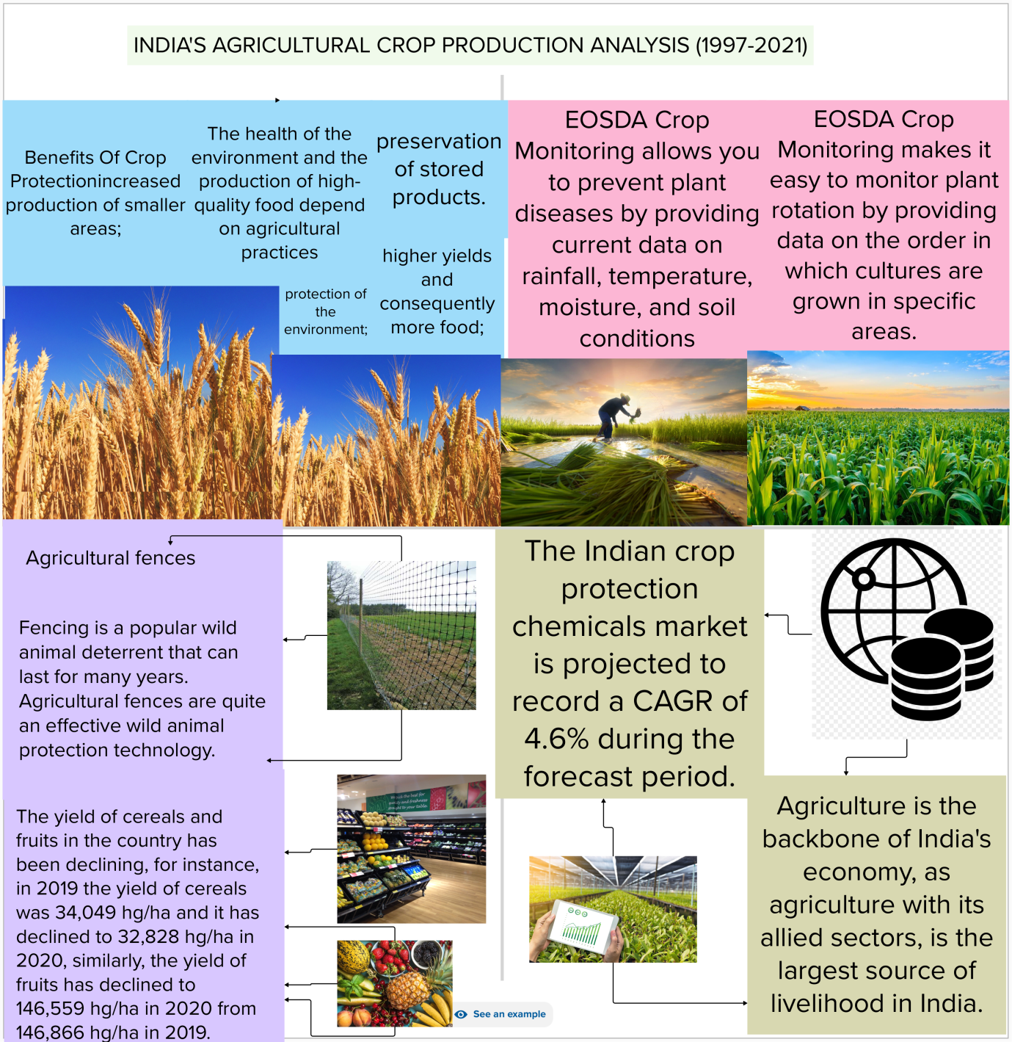

2.2.Ideution and Brainstorming:

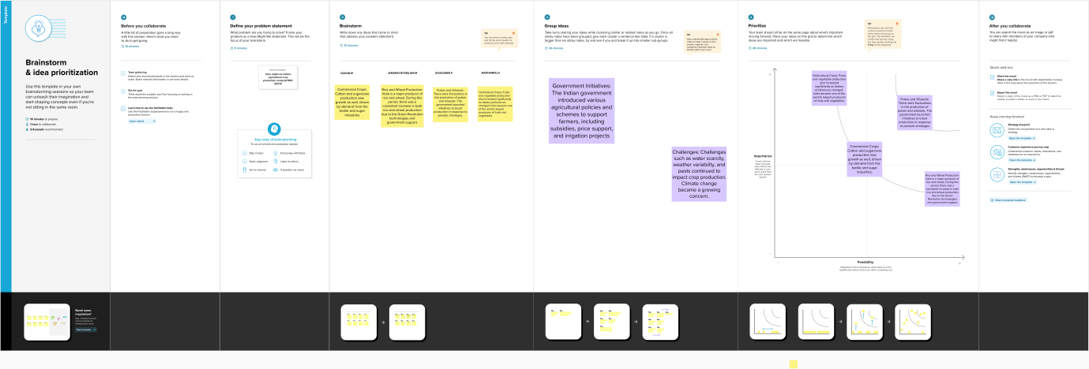

**3.Result**

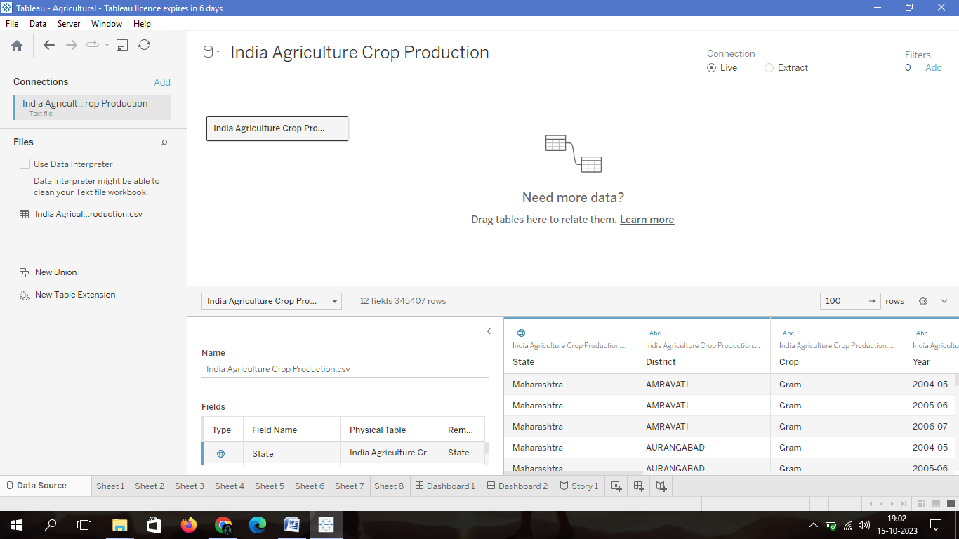

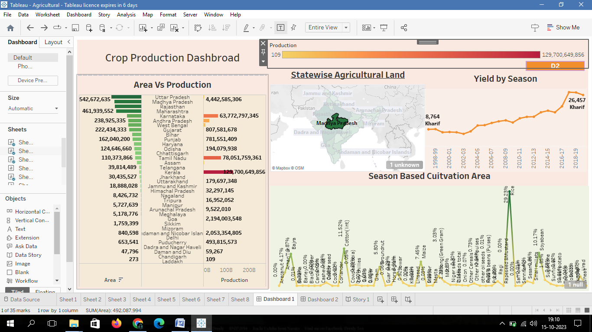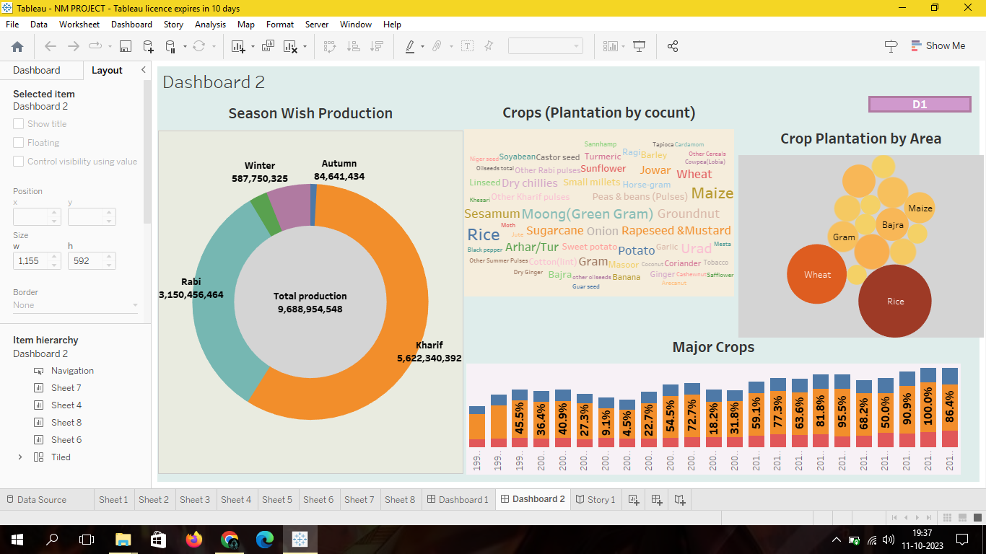

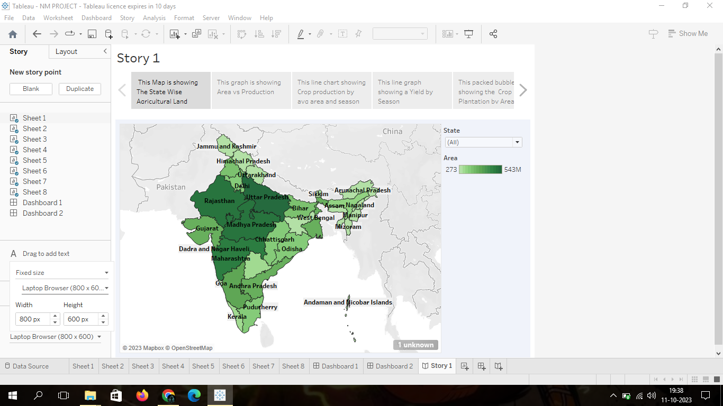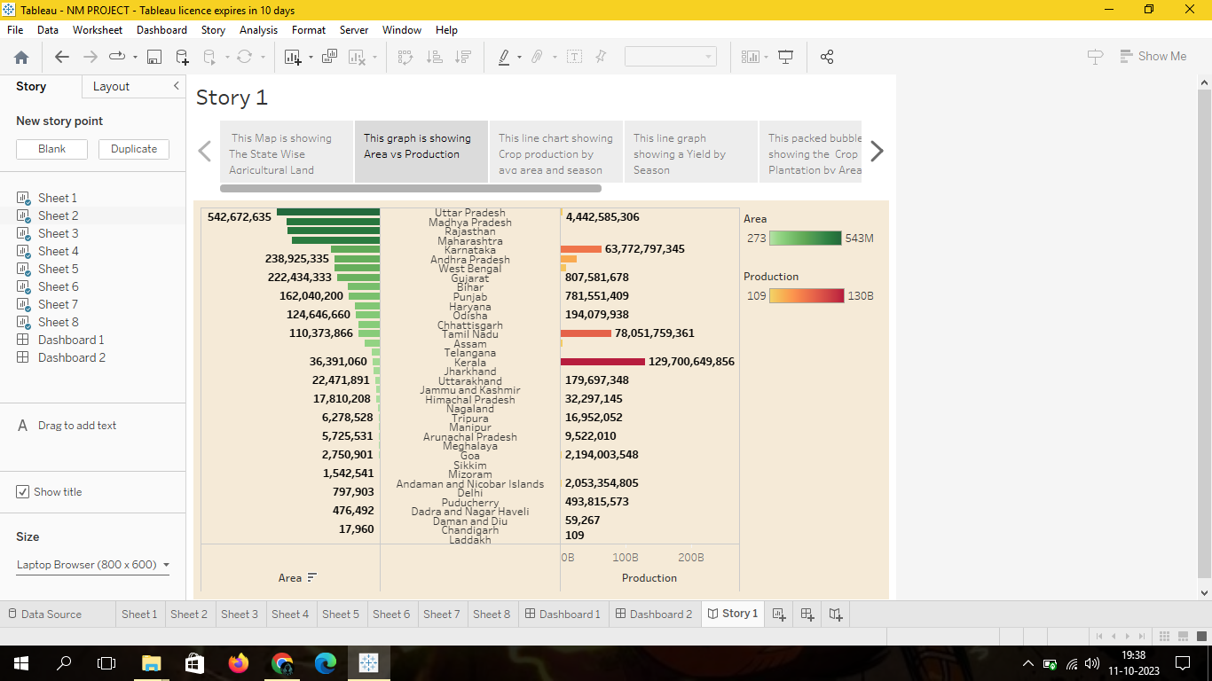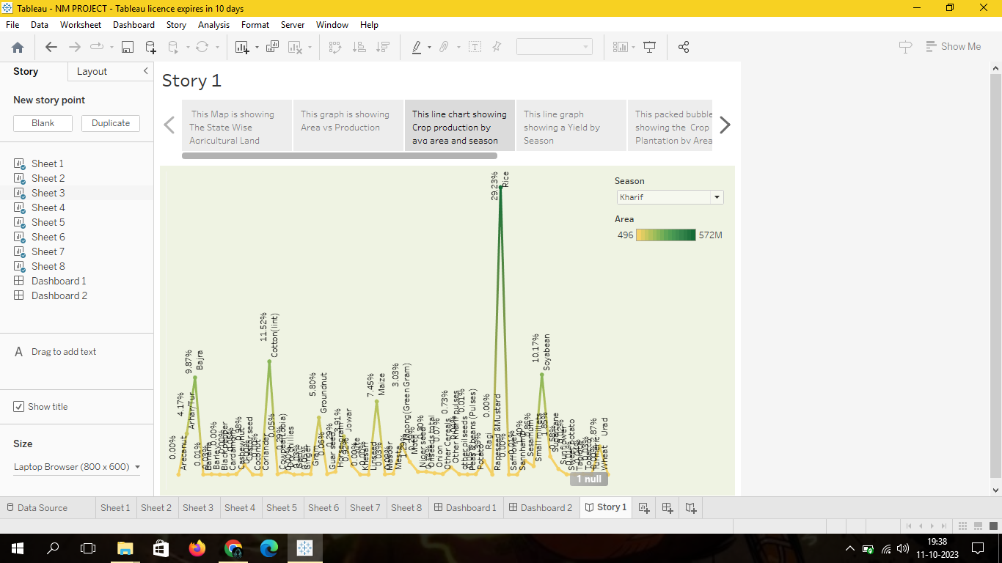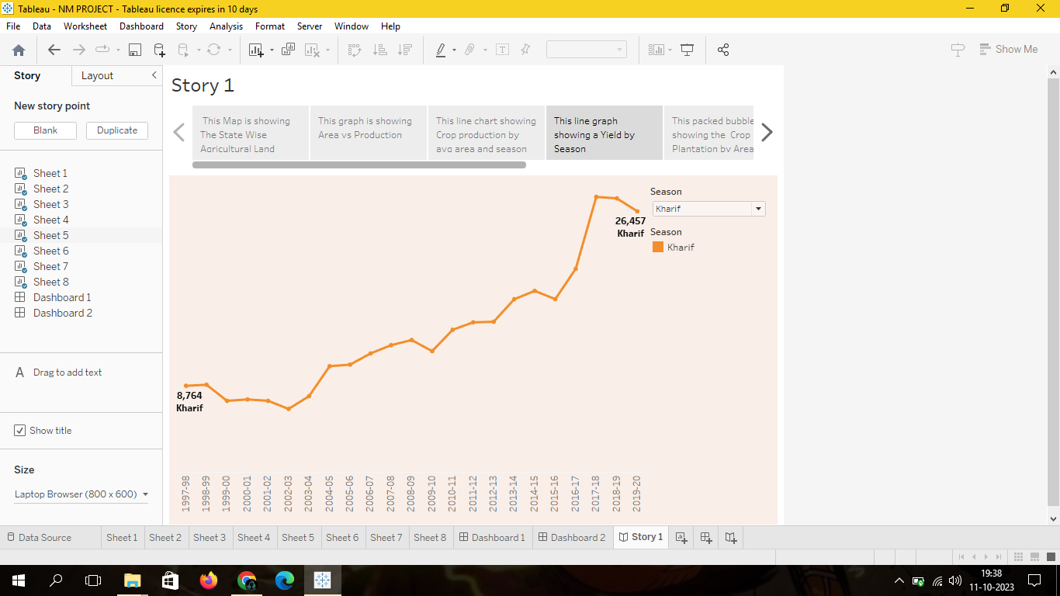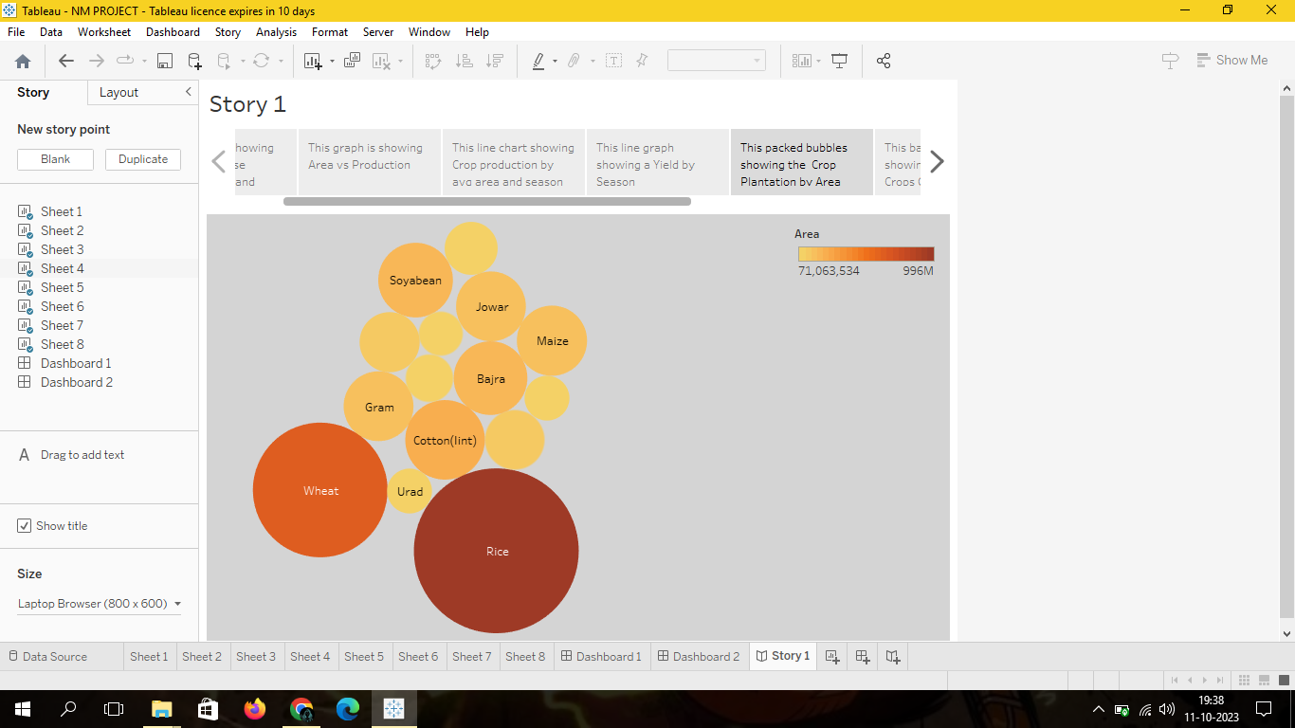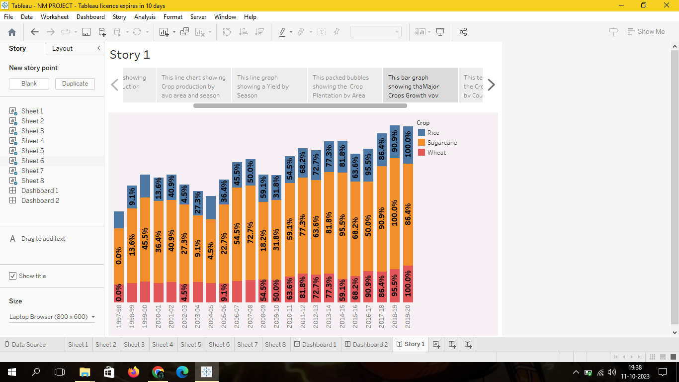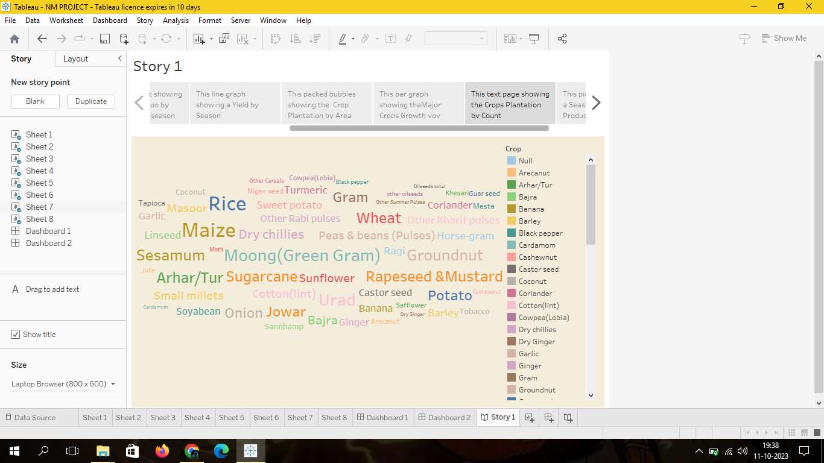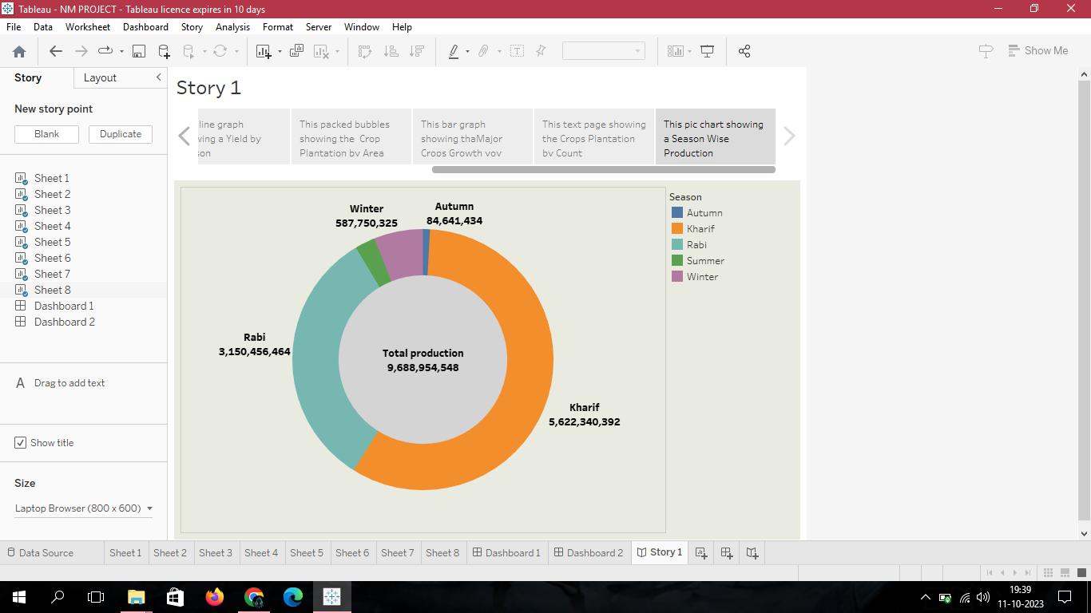

**4.Advantages & Disadvantages**

Food Security:

Crop production ensures a stable and consistent food supply, contributing to food security for the large and diverse population of India.

Rural Development:

Successful crop production is linked to rural development, creating economic opportunities, improving infrastructure, and enhancing the quality of life in rural areas.

**Disadvantages and Challenges:**

Low Productivity:

Many farmers in India face low crop yields due to outdated farming techniques, inadequate access to technology, and a lack of knowledge about advanced agricultural practices.

Fragmented Land Holdings:

The majority of farmers have small and fragmented land holdings, making it challenging to implement large-scale, efficient farming practices.

Climate Change Impact:

Changing weather patterns and unpredictable climatic conditions pose threats to crop production, leading to uncertainties and risks for farmers.

Water Scarcity and Irrigation Issues:

Insufficient and inefficient irrigation systems contribute to water scarcity, impacting crop yields and agricultural sustainability.

Market Access and Price Volatility:

Farmers often face challenges in accessing markets, and price volatility can lead to uncertain incomes. Lack of information about market trends adds to this issue.

Environmental Concerns:

Intensive farming practices, including excessive use of fertilizers and pesticides, can lead to environmental degradation, soil erosion, and water pollution.

Rural Poverty:

Despite being a significant source of employment, agriculture often faces issues of low income and rural poverty, affecting the overall well-being of farming communities.

**5.Applications**

Livelihoods and Employment:

Agriculture is a major source of livelihood for a significant portion of the population. Crop production provides employment opportunities for millions of farmers, agricultural laborers, and those involved in the agro-processing industry.

Rural Development:

Successful crop production plays a crucial role in rural development. It creates employment opportunities, improves infrastructure, and enhances the overall quality of life in rural areas.

Research and Innovation:

Agricultural crop production stimulates research and innovation in areas such as crop science, genetics, and agrotechnology. This leads to the development of improved crop varieties, pest-resistant plants, and innovative farming practices

Government Initiatives:

Crop production is integral to various government initiatives aimed at improving agricultural productivity, ensuring farmers' welfare, and promoting sustainable farming practices.

**6.Conclutions**

Critical Role in Economy: India's agricultural crop production plays a crucial role in the country's economy, contributing significantly to GDP, employment, and the overall well-being of the population.

Food Security:

Crop production is fundamental to ensuring food security for India's large and diverse population, providing a stable supply of staples and diverse food items.

Employment Generation:

Agriculture remains a major source of employment, supporting millions of farmers, agricultural laborers, and workers in the agribusiness sector.

Challenges Exist:

Despite its importance, Indian agriculture faces numerous challenges, including low productivity, fragmented land holdings, climate change impacts, water scarcity, and post-harvest losses.

Need for Sustainability:

The future of Indian agriculture hinges on sustainable practices that balance economic growth with environmental conservation, ensuring long-term viability.

**7.Future Scope:**

Technology Adoption:

Embracing advanced agricultural technologies, including precision farming, IoT, and AI, can enhance productivity, reduce resource use, and make farming more efficient.

Climate-Resilient Agriculture:

Developing and promoting climate-resilient crop varieties and farming practices will help Indian agriculture adapt to changing weather patterns and reduce vulnerability.

Water Management:

Implementing efficient water management practices, such as drip irrigation and rainwater harvesting, is crucial to address water scarcity and ensure sustainable water use.

Organic Farming:

Encouraging and supporting organic farming practices can promote environmental sustainability, reduce chemical inputs, and meet the growing demand for organic products.

Skill Development:

Investing in farmer education and skill development programs will empower farmers with knowledge about modern farming practices, technology usage, and sustainable agriculture.

Research and Development:

Continued investment in agricultural research is essential for developing new crop varieties, pest-resistant plants, and sustainable farming technologies.